
SVKM’s INSTITUTE OF TECHNOLOGY, DHULE
Department of Information Technology
Academic Year 2025-26

Experiment 5

Name: Bhupesh Anil Suryawanshi
Roll No.: 63
Batch: B3

Aim: To implement SOFM using character recognition

Theory :
Handwritten Digit Recognition is one of the most popular applications of Artificial Intelligence (AI), Machine Learning (ML), and Computer Vision. It is a process by which a computer system can read and identify handwritten digits (0–9) from sources such as scanned documents, digital images, or touchscreen inputs, and convert them into machine-readable form.
This task is a subset of image recognition and falls under pattern recognition, where the goal is to train a model that can correctly classify the image of a digit into one of ten classes (0–9). Handwritten digit recognition systems are used in bank cheque processing, postal code recognition, digitizing forms, and OCR (Optical Character Recognition) systems.
Handwritten Character Recognition
Handwritten Character Recognition (HCR) involves detecting, segmenting, and recognizing individual handwritten characters or digits. It uses ML algorithms to learn from image data, extract meaningful features, and predict the correct label for unseen data.
The general process includes:
- Input Image Acquisition: Capturing the handwritten digit image.
- Preprocessing: Cleaning and normalizing the image.
- Feature Extraction: Identifying the essential features such as edges, intensity, and structure.
- Classification: Using algorithms like SVM, k-NN, or Neural Networks to identify the digit.
- Evaluation: Measuring accuracy of the model.
Workflow of a Handwritten Digit Recognition System
Input Image → Preprocessing → Feature Extraction → Classification → Output (Predicted Digit)
- Input Image: The system takes an image of a handwritten digit as input.
- Preprocessing: The image is cleaned, resized, and normalized to remove noise.
- Feature Extraction: Important patterns and characteristics are identified from the image.
- Classification: A trained model classifies the digit using algorithms like SVM or k-NN.
- Output (Predicted Digit): The system displays the recognized digit (0–9) as the result.

Dataset Used : MNIST Dataset
The MNIST (Modified National Institute of Standards and Technology) dataset is a benchmark dataset widely used for handwritten digit recognition.
- It contains 70,000 grayscale images of digits (60,000 for training and 10,000 for testing).
- Each image is 28×28 pixels, representing digits 0–9.
- The dataset is balanced, meaning each digit has roughly equal samples.
Example :
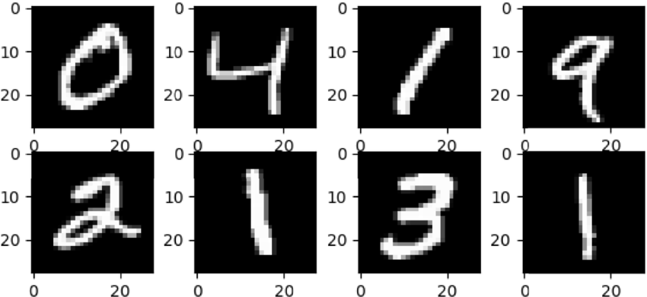
Steps Involved in Implementation :
- Download the MNIST dataset from sources such as Kaggle or TensorFlow/Keras datasets.
- Preprocess the dataset by normalizing pixel values (0–255 → 0–1) and reshaping images into a format suitable for ML models.
- Train the classifier using techniques like Support Vector Machine (SVM), k-Nearest Neighbor (k-NN), or Deep Neural Networks (DNN).
- Test the classifier on the unseen test dataset to evaluate its accuracy.

Techniques Used :
1. Support Vector Machine (SVM)
- SVM is a supervised learning algorithm that finds the optimal hyperplane to separate data points of different classes.
- In handwritten digit recognition, SVM classifies pixel intensity values into one of the 10 digit classes.
- It works well with high-dimensional data and provides high accuracy.
2. Nearest Neighbor (k-NN)
- The k-NN algorithm classifies a new image based on the closest samples (neighbors) in the training set.
- It computes the Euclidean distance between the test sample and each training sample.
- The class with the majority among nearest neighbors is assigned to the input image.

Performance Metric: Accuracy
To evaluate how well the model performs, accuracy is used as the main metric.
$$\text{Accuracy}=\frac{\text{Number of correctly classified digits}}{\text{Total number of test digits}}×100$$
Since the dataset is balanced, accuracy is an appropriate measure for performance comparison.
Advantages
- It reduces human effort by automating data entry from handwritten documents.
- It provides high accuracy with proper training and preprocessing.
- It supports real-time recognition on devices like tablets and touchscreens.
- It improves accessibility and efficiency in digital document processing.
Disadvantages
- It may fail if handwriting styles vary significantly.
- It requires a large labeled dataset for effective training.
- It can be computationally expensive for large neural models.
- It is sensitive to noise or poor image quality in the input.
Applications
- It is used in postal code and bank cheque recognition systems.
- It helps in digitizing handwritten documents into editable text.
- It is used in automated form reading and document analysis.
- It plays a key role in OCR systems and AI-driven writing assistants.
Conclusion:
The Handwritten Digit Recognition system was successfully implemented using the MNIST dataset. The experiment demonstrated how machine learning algorithms such as SVM and k-NN can accurately classify handwritten digits after preprocessing and feature extraction. The results showed that the model could effectively convert handwritten inputs into machine-readable form with high accuracy, proving its usefulness in real-world applications like document digitization and automated recognition systems.

Program:
import tensorflow as tf
from tensorflow import keras
import numpy as np
import matplotlib.pyplot as plt

# Import the mnist object from keras.datasets
from keras.datasets import mnist

# Load the dataset
(x_train, y_train), (x_test, y_test) = mnist.load_data()

# Check data sizes
len(x_train)
len(x_test)

# Display shape of one image
x_train[0].shape

# Display pixel values of one image
x_train[0]

# Display image
plt.matshow(x_train[1])
plt.title(f"Label: {y_train[1]}")
plt.show()

# Display labels
y_train[2]
y_train[:5]

# Normalize the data
x_train = x_train / 255
x_test = x_test / 255
# FLATTEN THE ARRAY
x_train_flattened = x_train.reshape(len(x_train), 28*28)
x_train_flattened.shape

x_test_flattened = x_test.reshape(len(x_test), 28*28)
x_test_flattened.shape

# Convert an image to array
arr = np.array(x_train[0])

# Display flattened first image array
x_train_flattened[0]

# Build the model
model = keras.Sequential([
keras.layers.Dense(10, input_shape=(784,), activation='sigmoid')
])

# Compile the model
model.compile(optimizer='adam',
loss='sparse_categorical_crossentropy',
metrics=['accuracy'])

# Train the model
model.fit(x_train_flattened, y_train, epochs=5)

# MODEL EVALUATION ON TESTING
model.evaluate(x_test_flattened, y_test)

# Display one test image
plt.matshow(x_test[0])
plt.title(f"Actual Label: {y_test[0]}")
plt.show()
# Predict on test data
from sklearn.metrics import confusion_matrix
import seaborn as sn
import matplotlib.pyplot as plt
import numpy as np

y_pred = model.predict(x_test_flattened)

# Convert predictions to class labels
y_pred_classes = [np.argmax(i) for i in y_pred]

# Create confusion matrix
conf_mat = confusion_matrix(y_test, y_pred_classes)

# Plot confusion matrix
plt.figure(figsize=(10,7))
sn.heatmap(conf_mat, annot=True, fmt='d')
plt.xlabel('Predicted')
plt.ylabel('Truth')
plt.show()

Output:
